Chapter 7, Solution 37.

Let v = v_{h} + v_{p}, v_{p} =10.

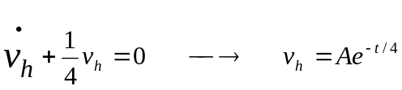

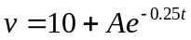

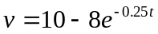

(a) 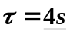

(b) 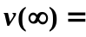 10 V

(c ) 